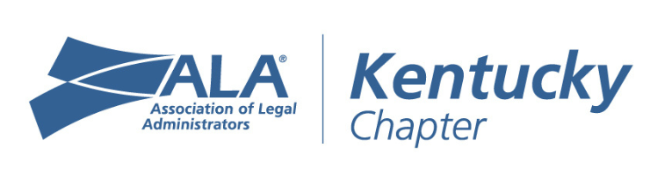

KYALA Chapter Meeting
July 9, 2026
11:45 am-1:00 pm

AGENDA

- Welcome
  - Welcome all members, BPs & thanks to FBT Gibbons for hosting

- Chapter Business
  - Approval of Minutes/Financial Reports
    - June 2026 Board & Chapter Minutes
    - June 2026 Financials
  - 2026 Calendar of Events
    - Member Meet up – 4th Thursday of the Month
    - July 16th-18th – Chapter Leadership Institute
    - July 22nd – BP Roundtable
    - August 7th – ALA Mental Health First Aid Certification
    - September 18-19th – Level Up: ALA’s Legal Management Fundamentals
    - September 24th-25th – Kentuckiana Retreat
    - October 21st – BP Keeneland Event

- Committees
  - Retreat Committee – Update on upcoming retreat

- Speakers/Presentation
  - Speaker: Becky Haggard
  - Presentation Topic: Mid-Year Legal Management Roundtable: Lessons, Challenges & Best Ideas

- Next KYALA Chapter Meeting – DON’T FORGET TO REGISTER!
  - In-Person & via Zoom: FBT Gibbons - Lexington and Louisville
  - Date & Time: August 13, 2026, 11:45 am – 1:00 pm
  - Speaker: TBD

